Detailed answers to the adult questionnaire 5 April 2022
General overview

Cystitis
Patients with cystitis should be treated with an appropriate antimicrobial agent. Before selecting a treatment regimen for patients with presumed cystitis, ask about factors that may influence the choice of antimicrobial agent, including pregnancy and breast-feeding, other medications being taken, drug allergy history, recent antibiotic therapy, other recent infections or positive cultures, and recent travel. Also, whether there are any complicating factors should be determined because management of uncomplicated cystitis and pyelonephritis differs from that of complicated UTI. The IDSA has recently published updated guidelines for treatment of uncomplicated cystitis and pyelonephritis, specifically in premenopausal, nonpregnant women with no known urologic abnormalities or comorbid conditions.
In addition to the usual concerns for efficacy and safety, the 2010 IDSA treatment recommendations for acute cystitis and pyelonephritis were guided by 2 important principles: the increasing prevalence of resistant organisms, and the potential for propagation of resistance (collateral damage) among normal host flora with the use of broad-spectrum antibiotics. No single agent was designated as the preferred regimen. Instead, agents are listed as recommended for first-line therapy (nitrofurantoin, TMP-SMX, pivmecillinam, and fosfomycin trometamol) and alternative agents (fluoroquinolones and beta-lactams). Each agent has its own caveats. Nitrofurantoin concentrates in the urine but has little tissue penetration and thus should be avoided if there is any possibility of pyelonephritis. A 5-day course of nitrofurantoin was as effective as a 3-day course of TMP-SMX in terms of both clinical and microbiological cure in a randomized trial. The main limitation to the use of TMP-SMX is the rising rate of resistance among uropathogens and consistent evidence that in vitro resistance correlates with bacterial and clinical failures in at least 50% of women. However, the 4 studies reviewed by the IDSA guidelines committee showed that TMP-SMX remains an appropriate empirical treatment for acute uncomplicated cystitis in women when the local rate of resistance is known or expected to be < 20%.

Fosfomycin. The recommended 3-g single dose may not be as efficacious as other recommended agents, and it should be not be used if pyelonephritis is suspected. Susceptibility data are not routinely reported for this drug, but surveys demonstrate that it retains activity against multidrug resistant uropathogens, such as extended-spectrum beta-lactamase–producing gram-negative organisms.
Pivmecillinam, is an extended-spectrum penicillin that is active against gram-negative organisms but is used only for treatment of UTI. Although efficacy rates are lower than those of the other recommended agents, its low resistance rates have made it a popular first-line choice in some European countries.
Fluoroquinolones, ofloxacin, ciprofloxacin, and levofloxacin, are all highly efficacious in 3-day regimens but are recommended as alternative agents because they have a high propensity for collateral damage of the normal fecal flora. Increasing rates of fluoroquinolone resistance in certain areas suggest that these agents should be reserved for conditions other than acute cystitis. Beta-lactams in general have inferior efficacy, high collateral damage, and greater rates of adverse effects than other UTI antimicrobials and thus are also considered alternative agents.
Pyelonephritis
Pyelonephritis is a tissue-invasive disease, and the initial empirical regimen should be broad enough to ensure in vitro activity against the uropathogen. In all suspected cases, a urine culture would ideally be obtained for susceptibility testing before starting therapy so the initial empirical therapy can be tailored appropriately. The decision points in managing acute pyelonephritis include ruling out complicated infection (pregnancy, nephrolithiasis, obstruction) and then determining whether the patient can take oral antibiotics as an outpatient.
If oral therapy is feasible, oral ciprofloxacin in a 7-day regimen is the preferred regimen if local resistance rates to the fluoroquinolones do not exceed 10%. The extended-release formulation of ciprofloxacin for 7 days or a once-daily dose of levofloxacin for 5 days can also be used, albeit the evidence is not as robust.
TMP-SMX is also effective if the pathogen is susceptible, but in the absence of evidence to support short-course therapy a 14-day course is the official recommendation. If susceptibility of the uro-pathogen is not known, an initial single IV dose of ceftriaxone or a long-acting aminoglycoside is recommended before outpatient oral therapy. In a study comparing ciprofloxacin to TMP-SMX, an initial dose of IV ceftriaxone resulted in improved outcomes in women receiving TMP-SMX who had a resistant uropathogen. Oral beta-lactam agents are not recommended for treatment of pyelonephritis given inferior efficacy rates.
In women being admitted for IV therapy, a broad-spectrum agent should be given until the susceptibilities of the organism are known. This can be achieved with a carbapenem agent or an aminoglycoside with or without ampicillin, or extended spectrum beta-lactam with or without an aminoglycoside, or another regimen chosen on the basis of local resistance patterns.
Urinary analgesics for acute cystitis are appropriate in certain situations to speed resolution of bladder discomfort. The analgesic phenazopyridine is widely used but may cause nausea. Combination analgesics containing urinary antiseptics (methenamine, methylene blue), a urine-acidifying agent (sodium phosphate), and an antispasmodic agent (hyoscamine) are also available. Because these analgesics can mask the symptoms of antimicrobial failure, they are best used in patients with a clear diagnosis of cystitis.
Patients with underlying complicating conditions are more likely to have a drug-resistant organism, to exhibit a poor response to antimicrobial therapy even when the urine organism is susceptible, and to develop complications if initial therapy for UTI is suboptimal. Broader-spectrum empirical therapy with agents to which resistance is least common and longer treatment durations are measures intended to blunt the negative effects of host compromise on treatment outcomes. In clinical trials of therapy for complicated UTI, oral fluoroquinolones were as effective as traditional iv regimens and as or even more effective than oral TMP-SMX or TMP (particularly for organisms resistant to TMP-SMX). However, resistance to fluoroquinolones among uropathogens is increasing worldwide. If the local prevalence of fluoroquinolone resistance exceeds 10%, another broad-spectrum antimicrobial should be considered, including an extended-spectrum cephalosporin with or without an aminoglycoside or a carbapenem. Combinations of a beta-lactam and a beta-lactamase inhibitor (e.g., ampicillin-sulbactam, ticarcillin-clavulanate, and piperacillin-tazobactam) could also be considered.
The IDSA has issued evidence-based guidelines on the diagnosis, prevention, and treatment of CAUTI . The goal of limiting exposure to antimicrobial therapy and thus limiting selection pressure for resistant organisms is balanced by the awareness that microbial eradication requires a longer duration of therapy in patients with a urinary catheter. Seven days is the recommended duration of antimicrobial treatment for patients whose symptoms resolve promptly, and 10 to 14 days is recommended for patients with a delayed response. For those with CAUTI who are not severely ill, a 5-day regimen of levofloxacin may be considered.
In pregnant women with symptomatic UTI, a urine culture and susceptibility testing should be performed. Empirical therapy with an oral antimicrobial agent that is safe for use in pregnancy should be given for 3 to 7 days for cystitis or 7 to 14 days for pyelonephritis. Antibiotic therapy should be adjusted on the basis of culture results.

# Case 1: G6PD. To assess awareness of safe drugs in G6PD
A 21-year-old woman presents with severe dysuria, frequency and urgency for 2 days. She continues to be symptomatic despite taking plenty of fluids. She has G6PD deficiency. Will you start her on empirical therapy? Yes/No
- Is it important to send a urine sample for culture and sensitivity? Yes/No
- If empirical treatment is planned, which antimicrobial would be appropriate for her? Tick all the appropriate options. Please put the order of preference: 1, 2, 3 etc.

- Nitrofurantoin
- Fosfomycin
- Trimethoprim- sulphamethoxazole (Septran)
- Levofloxacin
- Ciprofloxacin
- Amoxicillin
- Amoxycillin-clavulanic acid
- Cefuroxime
- Cefalexin

Notes
What is G6PD Deficiency?
- Glucose-6-phosphate dehydrogenase (G6PD) is an enzyme that helps defend red blood cells against oxidative stress, thus deficiency can cause hemolytic anemia. G6PD deficiency is the world's most common enzyme deficiency and affects more than 400 million people. It is X-linked and more common in people of Mediterranean, African, and Asian descent.
- A typical attack of haemolytic anaemia in G6PD-deficient patients occurs within several days after exposure to oxidative stress, usually no treatment is needed and the patient will recover quickly.
- Haemolytic anaemia can be worsened by vitamin B₁₂ and folic acid deficiency. The patients respond very well to vitamin B₁₂ and folic acid. Folic acid acts as an antioxidant and may help in decreasing haemolysis.
- Quick resolution of haemolysis in G6PD deficiency requires sufficient erythropoiesis for which vitamin B₁₂ and folic acid are also necessary. Most episodes of haemolytic anaemia can be prevented by avoiding fava beans, oxidant drugs and oxidant chemicals.
- van de Mheen L, Smits SM, Terpstra WE, Leyte A, Bekedam DJ, van den Akker ES. Haemolytic anaemia after nitrofurantoin treatment in a pregnant woman with G6PD deficiency. BMJ Case Rep. 2014;2014:bcr2013010087. Published 2014 Apr 30. doi:10.1136/bcr-2013-010087
Antimicrobials which are safe in G6PD deficiency
- Nitrofurantoin: Little hemolysis in short term therapy (5 day therapy). In chronic prophylaxis, one needs to check G6PD status and avoid Nitrofurantoin.
- Cefuroxime/ cefuroxime axetil: It has equal efficacy to amoxicillin/clavulanate in comparator studies in the treatment of UTI. It has good activity against E. coli and Klebsiella spp. causing UTI. If taken with food is better absorbed and less likely to cause diarrhea, nausea, vomiting and abdominal pain. It may have a lower rate of associated diarrhea than ampicillin or amoxicillin.
- Amoxicillin: Up to 55% of bacterial isolates causing uncomplicated acute bacterial cystitis or acute bacterial pyelonephritis are resistant to amoxicillin thereby limiting its use as an empiric therapy. Highly efficacious for group B strep, other sensitive Gram positive cocci, and sensitive E. coli strains due to high bladder concentrations and excellent penetration of renal tissue. First-line therapy if the etiology known to be due to a Gram positive organism, e.g. S. saprophyticus.
- Sulfonamides may be considered first-line agents during the second and third trimesters.
- Theoretical risk of neural tube defects with TMP/SMX during first trimester.
- Theoretical risk of kernicterus with near-term use of sulfonamides, although no such association in 2013 Klarskov study.
Antimicrobials not to be given in G6PD deficiency:
- Nitrofurantoin, septran, fluoroquinolones, phenazopyridine (alkalysing agent for symptomatic management)
- Medications that were previously considered unsafe in G6PD deficiency but now have been considered to be possibly safe by some sources include fluoroquinolones and cotrimoxazole. Others disagree and argue that even isolated reports of adverse effects should be taken seriously.
CLINICAL VIGNETTE G6PD Deficiency and a Family’s Myth of Medication Allergies Tiffany Sheh, M.D., and IChen (Sally) Tsai, M.D..Proceedings of UCLA Healthcare-VOLUME 20 (2016)-

What does one mean by deferring antibiotics/with holding antibiotics for 48 hours?
With-holding antibiotics for 48 hours in healthy women with cystitis is suggested in many guidelines (NICE/ IDSA) and telling them to have the antibiotic if symptoms worsen or do not improve. Studies have shown that UTI is self limited in many women and symptomatic management is as good as antimicrobials given.
Symptomatic Treatment (Ibuprofen) or Antibiotics (Ciprofloxacin) for Uncomplicated Urinary Tract Infection? - Results of a Randomized Controlled Pilot Trial - Medscape - Jun 14, 2010
General overview: Treatment of uncomplicated cystitis in healthy non-pregnant women
Recommended drugs for cystitis
First line:
- Nitrofurantoin is advantageous in lower UTI as it concentrates in the lower urinary tract while maintaining a low serum concentration, acts against most Gram positive as well as Gram negative bacilli and also does not significantly affect bowel flora- little collateral damage- which may be the reason for lower resistance- It retains activity against ESBL. It is not very effective against Klebsiella and not at all against Proteus, Enterobacter and Pseudomonas. Note: Consider use of a different empiric agent in patients with suspected pyelonephritis, patients who have received nitrofurantoin in the last 3 months, or patients who have had a urine isolate with documented resistance to nitrofurantoin in the last 3 months Note: Nitrofurantoin use is contraindicated in pregnant patients at term (38 to 42 weeks' gestation), during labor and delivery, or when the onset of labor is imminent due to the possibility of hemolytic anemia in the newborn
- Nitrofurantoin ⃰
Macrocrystals 100 mg PO twice daily X 5d: minimal resistance and comparable efficacy
- Trimethoprim/sulfamethoxazole ⃰ ⃰
- (160/800 mg) DS 1 tab PO twice daily x 3d
TMP/SMX: Use if local prevalence of E. coli resistance to TMP-SMX ≤ 20% and if not used to Rx UTI in past 3 months. Not effective in Pseudomonas/Enterococcus
- Fosfomycin trometamol
- 3 g PO x single dose.-lower efficacy
Fosfomycin is not active against S. saprophyticus and Acinetobacter
- Pivmecillinam
- 400 mg PO twice daily X 5 d. Lower efficacy
- ⃰ Not effective in Proteus, Enterobacter and Pseudomonas infections
- ⃰ ⃰ Not effective in Pseudomonas/Enterococcus

Second line: Good to consult with Microbiologist
- Fluoroquinolones: To be used only if: severe symptoms / allergy to first-line agents /other Abx treatment in prior 3 months.
- Ciprofloxacin 250 mg PO twice daily x 3d
- Levofloxacin 250mg once daily x 3d
- Inferior options: test of cure advised-
- Amoxicillin/clavulanate 500/125 mg PO twice daily x 3-7 d
- Cephalosporins: Resistance to 1st and 2nd gen cephalosporins is usually high. Refer to local ABG
- Cefalexin-2nd 500 mg PO twice daily x 3-7d
- Cefuroxime-3rd 500 mg PO twice daily x 3-7d
- Cefpodoxime 100-200 mg twice daily x 3-7d
- Cefixime 400 mg daily x 3-7d

#Case 2 for Medicine and Surgery: Dilemma of treating Asymptomatic UTI, Importance of sending only relevant investigations
A 67-year-old female is scheduled for an elective total knee arthroplasty in a week’s time. As part of her pre-operative evaluation a urine analysis and culture were ordered. Pyuria and a significant count (10⁵ cfu/ml) of E. coli sensitive to nitrofurantoin, ciprofloxacin, trimethoprim-sulphamethoxazole, gentamicin and resistant to ampicillin, ceftriaxone, amoxicillin-clavulanic acid was reported. She has no symptoms of UTI. Which of the following options are correct?
- Antimicrobial therapy with ciprofloxacin 750mg BD for 5 days.
- Antimicrobial therapy with macrocrystals of nitrofurantoin 100mg BD for 5 days
- Screening for asymptomatic bacteriuria was unnecessary as the surgical procedure does not involve the GU tract.
- No antimicrobial treatment needed as she does not have any symptoms
Ans:
C and D

When should asymptomatic bacteriuria be treated?
Only in pregnant women and after clinical assessment in immunosuppressed individuals.
Need of the hour: Prevent unnecessary antimicrobial use in asymptomatic bacteriuria (ASB). ASB is a common cause of unnecessary antimicrobial use. This case study highlights that one should discourage unnecessary investigations. Once one gets a positive report it is very difficult to NOT prescribe antibiotics. It is also very difficult to stop an antimicrobial once initiated in the Emergency Dept. Hence their education is important.
- Treatment of ASB with antibiotics:
- Does not prevent future UTIs or sepsis.
- 3-10 patients will experience a negative outcome.
- Antibiotic exposure increases risk of:
- Bacteria developing resistance
- Adverse, allergic reactions
- C. difficile infection and a lot of collateral damage.
- No demonstrated benefit EXCEPT in pregnancy or if patient undergoing an invasive urologic procedure.
What do you understand by collateral damage in the context of antimicrobial use?

Fluoroquinolones have been linked to infection with methicillin-resistant S. aureus and increasing fluoroquinolone resistance in gram-negative bacilli, such as P. aeruginosa, Broad spectrum cephalosporins have been linked to subsequent infections with vancomycin-resistant Enterococci, ESBL–producing K. pneumoniae, β-lactam-resistant Acinetobacter species, and C. difficile.
Collateral damage describes ecological adverse effects of antimicrobial therapy, such as alterations of the normal gut microbiome that can help select drug-resistant organisms and promote colonization or infection MDR organisms.
The effects of specific antibiotics on the normal fecal flora promote drug resistance and increased pathogenicity.
E. coli isolates continue to demonstrate high in vitro susceptibility to nitrofurantoin, fosfomycin, and mecillinam. These antimicrobials have minimal effects on the normal fecal microbiota.
In contrast, antimicrobials that alter the fecal flora more significantly, such as trimethoprim-sulfamethoxazole (TMP-SMX) and fluoroquinolones, promote increased rates of antimicrobial resistance.

#Case 2: For Obs and Gynae-Identifying if UTI is being screened for in pregnant women
A 34-year-old Gravida 3 Para 2 woman in her first trimester comes for an ante-natal checkup in the local health centre. She is healthy and has no complaints.
Which screening tests should be ordered for her?
Ans: CBC, ante natal blood group and antibody screen, HbA1c if no blood sugar screening done, Urine for culture and sensitivity, HBV, HCV, HIV, Syphilis, Rubella
When should Group B Streptococcal screening be done?
Ans: Universal vaginal and rectal screening of all women at 35-37 weeks gestation with Rx of positive cases.

# Case 3: Prescribing ettiquette in pregnant and non pregnant women/men in cystits- to emphasize pre-eminent role of nitrofurantoin, fosfomycin, cotrimoxazole
A 24-year-old primigravida woman presents at 32 weeks of gestation with severe dysuria, frequency and urgency for 2 days.
Will you start her on empirical therapy? Yes/No
- Is it important to send a urine sample for culture and sensitivity? Yes/No
- If empirical treatment is planned, which antimicrobial would be appropriate for her? Tick all the appropriate options. Please put the order of preference, 1, 2, 3 etc.

What should be prescribed?

- Nitrofurantoin (avoid at term) 1st choice (Note: Nitrofurantoin use is contraindicated in pregnant patients at term (38 to 42 weeks' gestation), during labor and delivery, or when the onset of labor is imminent due to the possibility of hemolytic anemia in the newborn )
- Fosfomycin 4
- Trimethoprim- sulphamethoxazole (Septran)
- Levofloxacin
- Amoxicillin 2 ⃰ ⃰
- Cefalexin 3 ⃰
- Amoxicillin-clavulanic acid
⃰ Will depend on the susceptibility profile
What should be discouraged?
- Amoxicillin-clavulanic acid #
- Trimethoprim sulphamethoxazole (TMP/ SMX) §¥
- Levofloxacin §
- § TMP/SMX and fluoroquinolones are contra-indicated in pregnancy
- ¥ May be considered first-line agents during the second and third trimesters.Theoretical risk of neural tube defects with TMP/SMX during first trimester. Theoretical risk of kernicterus with near-term use of sulfonamides,
- §Trimethoprim is a potent folic acid antagonist and must be avoided in the first 3 months of pregnancy
Treatment of uncomplicated cystitis: Healthy pregnant women
- Nitrofurantoin ⃰
Macrocrystals 100 mg PO twice daily X 5d: minimal resistance and comparable efficacy
- Trimethoprim/sulfamethoxazole ⃰ ⃰
(160/800 mg) DS 1 tab PO twice daily x 3d (Second/Third trimester)
TMP/SMX: Use if local prevalence of E. coli resistance to TMP-SMX ≤ 20% and if not used to Rx UTI in past 3 months.
- Fosfomycin trometamol ⃰ ⃰ ⃰ 3 g PO x single dose.-lower efficacy
- Pivmecillinam
400 mg PO twice daily X 5 d. Lower efficacy
- 1st and 2nd Cephalosporins: Resistance to 1st and 2nd gen cephalosporins is usually high. Refer to Microbiologist.
Cephalexin 500 mg PO twice daily x 3-7d
Cefuroxime axetil 500 mg PO twice daily x 3-7d
⃰ Not effective in Proteus and Pseudomonas infections
⃰ ⃰ Not effective in Pseudomonas/Enterococcus
⃰ ⃰ ⃰ Not effective against S. saprophyticus
Second line treatment
- Fluoroquinolones: To be used only if: severe symptoms / allergy to first-line agents /other Abx treatment in prior 3 months.
- Ciprofloxacin 250 mg PO twice daily x 3d
- Levofloxacin 250mg once daily x 3d
- Inferior options: test of cure advised-
- Amoxicillin/clavulanate 500/125 mg PO twice daily x 3-7 d
- Cephalosporins:Refer to local ABG
- Cefpodoxime 100-200 mg twice daily x 3-7d
- Cefixime 400 mg daily x 3-7d

# Case 4: To assess prescribing etiquettes in pyelonephritis, pharmacodynamics and pharmacokinetics of renal tissue- emphasizing fluoroquinolone sparing protocol
A 38-year-old female presents with fever of 39.2⁰C, dysuria, frequency and urgency. She complains of pain in the costo-vertebral angle for the last three days. She is experiencing nausea and has had several episodes of vomiting.
Will you start her on empirical therapy? Yes/No
- Is it important to send a urine sample for culture and sensitivity? Yes/No
- What is the acceptable storage time of a urine sample at room temperature before it reaches the Microbiology laboratory?
  - 1 hr b. 2 hr c. 4 hr d. Overnight e. Not relevant
- If empirical treatment is planned, which antimicrobial would be appropriate for her? Tick all the appropriate options. Please put the order of preference, 1, 2, 3 etc.

- Nitrofurantoin
- Fosfomycin
- Trimethoprim- sulphamethoxazole (Septran)
- Ciprofloxacin
- Levofloxacin
- Amoxicillin-clavulanic acid
- Cefuroxime
- Cefazolin

- Treatment advised: #
As she is vomiting, initial administration will be iv followed by oral.
- Trimethoprim- sulphamethoxazole-1st
- Cefuroxime-2nd
- Amoxicillin-clavulanic acid-3rd
- Ciprofloxacin-4th
- Levofloxacin-5th
# Note: Cotrimoxazole, beta lactams, aminoglycosides and fluoroquinolones penetrate renal tissue well and thus are good drugs for pyelonephritis
Not to be prescribed:
- Not advised
Due to poor concentration in renal tissue
- Nitrofurantoin
- Fosfomycin
Resistance issues:
Cefazolin/ cephalexin
# Note # Order of preference is from narrow spectrum to broad spectrum
Fluoroquinolone Safety Alert: Disabling & potentially permanent adverse effects outweigh benefit in cystitis and pyelonephritis . Only use when no other alternatives exist.
Empiric oral outpatient Rx of acute uncomplicated pyelonephritis:
Non pregnant women, men and children
- NICE PHE guidelines: More conservative
- Cefalexin 500mg BD or TDS (up to 1g to 1.5g X 7-10 days
- Ciprofloxacin 500mg BD X 7 d
⃰ Amoxicillin-clavulanic acid 500/125mg TDS X 7-10 d
⃰ Trimethoprim 200mg BD X 14 d
⃰ Only if confirmed by c/s
Intravenous antibiotics as first choice -if vomiting, unable to take oral antibiotics, or severely unwell.
- Co-amoxiclav (only in combination or if culture results available and susceptible )1.2 g three times a day
- Cefuroxime 750 mg to 1.5 g three or four times a day
- Ceftriaxone 1 to 2 g once a day
- Ciprofloxacin (consider safety issues) 400 mg twice or three times a day
- Gentamicin Initially 5 mg/kg to 7 mg/kg once a day, subsequent doses adjusted according to serum gentamicin concentration
- Amikacin Initially 15 mg/kg once a day (maximum per dose 1.5 g once a day), subsequent doses adjusted according to serum amikacin concentration (maximum 15 g per course)
- Antibiotics may be combined if susceptibility or sepsis a concern
Second choice intravenous antibiotics - consult local microbiologist
- John Hopkins guidelines:
- Ciprofloxacin 500 mg PO twice daily x 7 d
- Levofloxacin 750 mg orally x 5-7 d
- if local rates of E. coli fluoroquinolone resistance are low (< 10%):
Initial dose of one of the following parenteral agent, if FQ resistance is >10% followed by treatment as guided by c/s results.
- Ceftriaxone 1 gm IM or IV x 1
- Gentamicin 5 mg/kg IM or IV x 1
- Ciprofloxacin 400 mg IV x 1
Intravenous antibiotics as first choice -if vomiting, unable to take oral antibiotics, or severely unwell. Note mention of combination therapy
- Ceftriaxone 1 g IV once daily (with or without an aminoglycoside, e.g., gentamicin 5 mg/kg IV daily)
- Gentamicin 5 mg/kg IV once daily (with or without ampicillin 2 grams IV q4h)
- Tobramycin 5 mg/kg IV once daily (with or without ampicillin 2 grams IV q4h)
- Ciprofloxacin 400 mg IV q12h (if local fluoroquinolone resistance rates < 10%)
- Levofloxacin 500 mg IV once daily (if local fluoroquinolone resistance rates < 10%)
- Piperacillin/tazobactam 3.375 g IV q6h (with or without an aminoglycoside, e.g., gentamicin 5 mg/kg IV daily)
- Meropenem 2 grams IV q8h
- Duration: typically 48h parenteral therapy or until afebrile, then switch to oral therapy based upon susceptibility data to complete 7d (fluoroquinolone) or 14d (TMP-SMX) course.
- If beta-lactam is used to complete therapy, 10-14 days duration needed.
- Suspected or proven Enterococcus spp. infection: ampicillin 2 g IV q4h plus aminoglycoside (e.g., gentamicin 5 mg/kg IV daily) for initial therapy, then complete 10-14 d therapy with amoxicillin if susceptible.
- Use local antibiotic susceptibility data to guide initial empiric therapy.

Pharmacokinetics and Pharmacokinetics
Time dependent antibiotics:
Beta lactams, vancomycin
Serum concentration shd exceed the MIC for the duration of the dosing interval:- continuous infusion or frequent dosing.
Concentration dependent antibiotics:
Aminoglycosides, fluoroquinolones, metronidazole
Have enhanced bactericidal activity as the serum concentration is increased. “Peak” serum concentration, and not the frequency of the dosing interval is important.
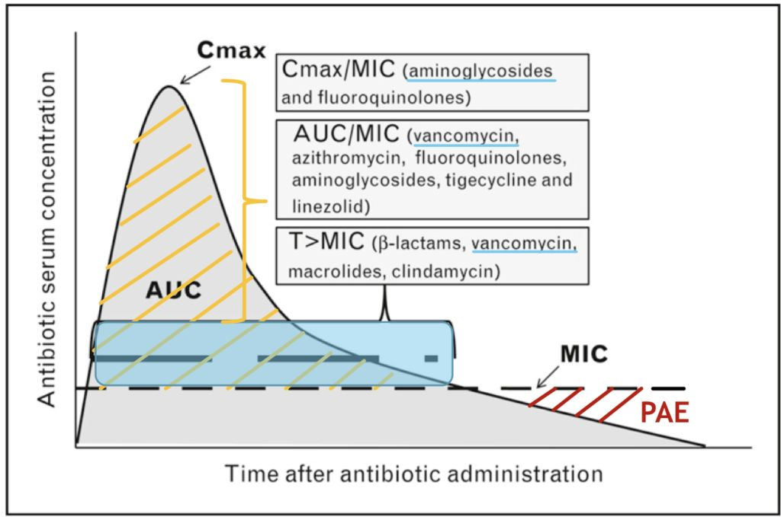
• Drugs. 2005;65(7):949-91. Guide to selection of fluoroquinolones in patients with lower respiratory tract infections. Shams WE, Evans ME.
Pharmacodynamic parameters:
- Minimum inhibitory concentration (MIC)
- Mutant prevention concentrations (MPC)
- Are useful to predict the effect of antibiotics in bacterial killing and the emergence of resistance.
Pharmacokinetic considerations:
- C (max): Peak concentration of the antibacterial after a dose
- (AUC24): 24-hour area under the concentration-time curve
- Higher C(max)/MIC or AUC24/MIC and C(max)/MPC or AUC24/MPC ratios, either as a result of dose administration or the susceptibility of the organism, may lead to a better clinical outcome and decrease the emergence of resistance, respectively.
- Drugs. 2005;65(7):949-91. Guide to selection of fluoroquinolones in patients with lower respiratory tract infections. Shams WE, Evans ME.
Notes:
A number of pharmacokinetic parameters such as the peak concentration of the antibacterial after a dose (C(max)), and the 24-hour area under the concentration-time curve (AUC24) and their relationship to pharmacodynamic parameters such as the minimum inhibitory and the mutant prevention concentrations (MIC and MPC, respectively) have been proposed to predict the effect of fluoroquinolones on bacterial killing and the emergence of resistance. Higher C(max)/MIC or AUC24/MIC and C(max)/MPC or AUC24/MPC ratios, either as a result of dose administration or the susceptibility of the organism, may lead to a better clinical outcome and decrease the emergence of resistance, respectively. Pharmacokinetic profiles that are optimised to target low-level resistant minor subpopulations of bacteria that often exist in infections may help preserve fluoroquinolones as a class. To this end, optimising the AUC24/MPC or C(max)/MPC ratios is important. For example in S. pneumoniae, in the setting of lower respiratory tract infections. moxifloxacin and gemifloxacin with high ratios against this organism are preferred, and agents such as ciprofloxacin with low ratios should be avoided. For agents such as levofloxacin and gatifloxacin, with intermediate ratios against S. pneumoniae, it may be worthwhile considering alternative dose administration strategies, such as using higher dosages, to eradicate low-level resistant variants. This must, of course, be balanced against the potential of toxicity. Innovative approaches to the use of fluoroquinolones are worth testing in further in vitro experiments as well as in clinical trials.
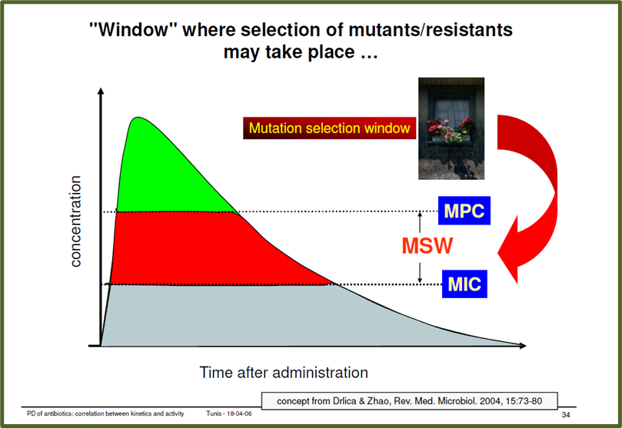
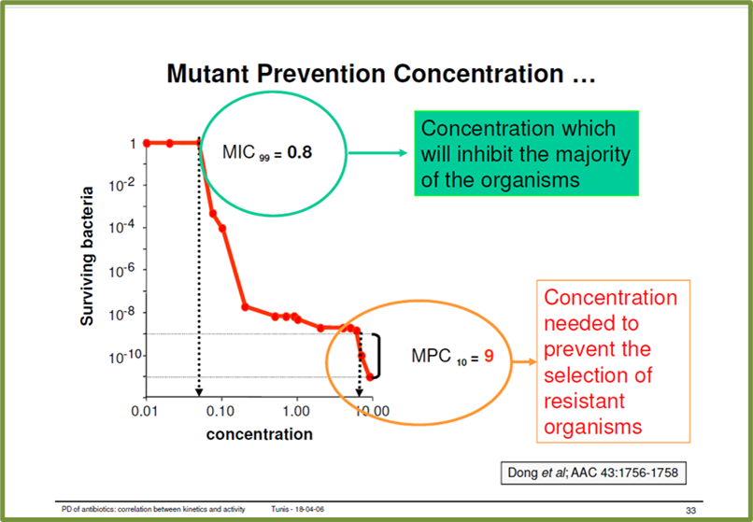
Improving outcomes from infection requires understanding of the interactions between the drug, host and infecting pathogen. Antimicrobial stewardship employs the clinical application of PK-PD principles while providing the narrowest coverage for the infection by optimizing the agent, dose and duration with the aim of the best control of infection whilst maintaining minimal impact on resistance selection. BSAC
Drugs. 2005;65(7):949-91.
Guide to selection of fluoroquinolones in patients with lower respiratory tract infections.
Shams WE¹, Evans ME.

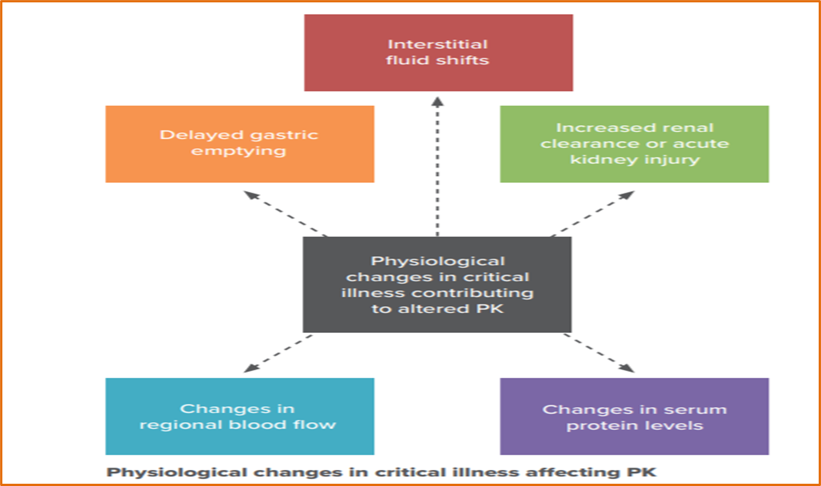

Empiric Rx of acute uncomplicated pyelonephritis: Pregnant women:
First line oral
- NICE guidelines: More conservative
- Cefalexin 500mg BD or TDS (up to 1g to 1.5g X 7-10 days
- First choice intravenous antibiotic
(if vomiting, unable to take oral antibiotics, or severely unwell)
- Cefuroxime 750 mg to 1.5 g three or four times a day X 14 days

John Hopkins Guidelines
Single-dose IV in ED then home with oral Rx for clinically stable and treatment-adherent patients.
Cefazolin 1g IV q8h until afebrile x 48h, then change to PO to complete 14d.
Ceftriaxone 1 g IV or IM q24h until afebrile x 48h, then change to PO to complete 14d. (Consider alternative therapy near-term given theoretical kernicterus risk.)
If allergy to above:
Gentamicin 2 mg/kg IV q8h and follow levels, then change to PO to complete 14d.
Sulfonamides first-line agents during the second and third trimesters.
Note: Adjust therapy as necessary upon return of culture results.
Note: Beta-lactam agents are less effective against uropathogens than fluoroquinolones, which cannot be used in pregnancy. Therefore, the total duration of treatment is longer (14d) than customary.

# Case 5: Assessing prescribing etiquette in asymptomatic UTI in pregnant woman
A 34-year-old pregnant woman with 28 weeks of gestation presented to the local ante-natal clinic with asymptomatic UTI. The urine culture and susceptibility report reads as follows:

Significant growth (10⁵ cfu/ml) of Escherichia coli isolated. The sensitivity is:

- Nitrofurantoin- S
- Fosfomycin-S
- Trimethoprim- sulphamethoxazole (Septran)-S
- Levofloxacin-S
- Amoxicillin-S
- Amoxicillin-clavulanic acid -S

Should this patient be treated? Yes/No
If yes, tick all the appropriate options. Please put the order of preference, 1, 2, 3 etc.
Our antimicrobial perspective:
Prescribe:
- Nitrofurantoin-1
- Fosfomycin-2
- Amoxicillin -3
- Cephalexin-4
- Amoxicillin-clavulanic acid-5
- Pivmecillinam (if available)
Not to be prescribed
- Trimethoprim- sulphamethoxazole –S *
- Ciprofloxacin-S
* First-line agents during the second and third trimesters.
Treatment of asymptomatic UTI: Healthy pregnant women
Nice Guidelines
- Nitrofurantoin
- Amoxicillin
- Cefalexin ⃰
⃰ based on recent culture and susceptibility results
John Hopkins Guidelines
- Nitrofurantoin ⃰ Macrocrystals 100 mg PO twice daily X 5d
- Cephalexin 500 mg PO BD x 3-7d
- Cefuroxime axetil 500 mg PO BD x 3-7d
- Fosfomycin trometamol
- Sulfonamides:
- first-line agents during the second and third trimesters.

- ⃰ Consider alternative therapy near-term in G6PD-deficient mothers given theoretical risk of maternal and fetal hemolytic anemia.

# Case 6: Assessing prescribing etiquette in acute cystitis caused by ESBL producing Klebsiella pneumoniae
A 64-year-old diabetic gentleman presents with severe symptoms of UTI. He is afebrile, alert and has no abdominal or costo-vertebral pain. A urine sample is sent to the Microbiology Lab and he is given amoxicillin-clavulanic acid 500/125mg TDS x7 days empirically. He is told to come back if symptoms persist.
He comes back on the third day with no relief in symptoms. The Microbiology report has just arrived and it reads as follows:
Significant growth of ESBL Klebsiella pneumoniae isolated. The sensitivity is:

- Ampicillin-R
- Amoxicillin-clavulanic acid-R
- Ceftazidime-R
- Ciprofloxacin-S
- Ceftriaxone-R
- Cefuroxime-R
- Cefepime-R
- Gentamicin-S
- Nitrofurantoin- S
- Fosfomycin-S
- Trimethoprim- sulphamethoxazole (Septran)-S
- Piperacillin-tazobactam-S
Please tick the antibiotic you would prefer to give and also put the order of preference, 1, 2, 3 etc. Please note: The local resistance to fluoroquinolones is 8% and 12 % to septran.

Note: Resistance to amoxicillin- clavulanic acid may be due to acquired resistance to penicillin-b-lactamase inhibitor combinations is due to: (i)penicillinase hyperproduction due to the presence of the blaTEM-1 gene in small multicopy plasmids or strong promoters; (ii) overproduction of constitutive AmpC cephalosporinase; and (iii) OXA-type and inhibitor-resistant TEM (IRT) b-lactamases. IRT enzymes emerge via mutational events from TEM-1 or TEM-2 b-lactamases that affect substrate affinity for b-lactamase inhibitors. They are mainly isolated in urinary infections from community patients.
Our antimicrobial perspective:
- Preferred drugs
- Nitrofurantoin
- Trimethoprim- sulphamethoxazole
- Fosfomycin⃰
- ⃰ Fos is ineffective in Kp due to FosA gene but is excellent in E.coli-the predominant bacteria in UTI
- Nitrofurantoin is ineffective against Pseudomonas and Tribe Proteae
Lower in preference
Gentamicin-S
Note: Aminoglycosides are nearly exclusively eliminated by the renal route in their active form. A single intravenous dose is generally effective for cystitis, with minimal toxicity, but robust trial data are lacking
Piperacillin-tazobactam-S
Ciprofloxacin-S
Meropenem-S
Clinical significance of ESBL:
- ESBLs are enzymes that inactivate most penicillins, oxyimino cehalosporins (cefuroxime, cefotaxime, ceftazidime, cefepime etc), and aztreonam.
- ESBLs do not inactivate cephamycins and non-β-lactam agents (nitrofurantoin, Fosfomycin, ciprofloxacin, trimethoprim-sulfamethoxazole, gentamicin).
- They remain susceptible to BL/BLI combinations (augmentin, cefoperazone- sulbactam and piperacillin-tazobactam).
- Organisms carrying ESBL genes often harbor additional genes or mutations in genes that mediate resistance to a broad range of antibiotics.
Oteo J, Perez-Vazquez M, Campos J. Extended-spectrum [beta]-lactamase producing Escherichia coli: changing epidemiology and clinical impact. Curr Opin Infect Dis. 2010;23: 320-6.

# Case 7: Assessing prescribing etiquette in acute prostatitis due to ESBL producing E. coli
# Case 7: A 57-year-old gentleman presents with symptoms suggestive of acute prostatitis. He is afebrile, alert and has low abdominal pain. A urine sample is sent to the Microbiology Lab and he is given ciprofloxacin 500mg BD for 14 days empirically. He is told to come back if symptoms persist.
He comes back on the fourth day with no relief in symptoms. The Microbiology report has arrived and it reads as follows:
Significant growth of ESBL Klebsiella pneumoniae isolated. The sensitivity is:

- Ampicillin-R
- Amoxicillin-clavulanic acid-R
- Ceftazidime-R
- Ciprofloxacin-R
- Ceftriaxone-R
- Cefuroxime-R
- Cefepime-R
- Gentamicin-S
- Nitrofurantoin- S
- Fosfomycin-S
- Trimethoprim- sulphamethoxazole (Septran)-S
- Piperacillin-tazobactam-S
- Meropenem-S
Please tick the antibiotic you would prefer to give and also put the order of preference, 1, 2, 3 etc. Please note: The local resistance to fluoroquinolones is 8% and 12 % to septran.
Interaction with audience:
Ask if the drug, dose, duration appropriate? Ciprofloxacin 500mg BD for 14 days empirically: Make it interactive. Free, non protein bound antibiotics penetrate well into the prostate. Fluoroquinolones and septran enter very well into the prostate. The intense inflammation in acute bacterial prostatitis (ABP) makes the prostate gland highly responsive to antibiotics, which otherwise penetrate poorly into the prostate. Consequently, outpatient therapy with oral antibiotics and supportive measures will suffice for most patients.
Fluoroquinolones are lipophilic, penetrate alkaline areas well and the acute inflammation also helps in penetration of most antimicrobials. Duration JH: 14-42days. Uptodate: 30 days. Mild cases with prompt response may require only 14d of abx. More severe cases and/or delayed response to therapy warrant 28-42d abx.
For prostatitis from ESBL-producing multidrug-resistant E coli, off-label treatment with oral fosfomycin has proved effective. The usual regimen is 3 g/24 hr for 1 week followed by 3 g/48 hr, for a total treatment duration of 6-12 weeks.
In prostatitis, the barrier between the microcirculation and the prostate gland stroma limits drug entry to passive diffusion, which only permits non-protein-bound, lipophilic antimicrobial agents to reach therapeutic levels within the gland. In addition, the low pH of prostatic fluid permits antibiotics with alkaline pKas (such as fluoroquinolones and sulfonamides) to achieve high concentrations in prostatic tissue more readily than antibiotics with acidic pKas. However, antibiotic prostatic penetration in the setting of inflammation occurs more readily. Antipyretics, analgesics, stool softeners, bed rest, and increased fluid intake provide supportive therapy. Hospitalization is required for patients in whom acute urinary retention develops and in those who require intravenous antimicrobial therapy.
Some resistant strains may require prolonged intravenous (IV) therapy. For IV therapy, use trimethoprim/sulfamethoxazole, 8-10 mg/kg/d (based on the trimethoprim component) in 2-4 doses two to four times daily until the culture and sensitivity results are known. An alternative regimen is gentamicin, 3-5 mg/kg/d IV in three divided doses, plus ampicillin 2 g in four divided doses. In addition, two approved β-lactam/β-lactamase inhibitor combinations, ceftolozane/tazobactam and ceftazidime/avibactam, have promising activity against multidrug-resistant Gram-negative organisms.
Antimicrobial stewardship perspective:
- Preferred drugs:#
- Trimethoprim- sulphamethoxazole-S (1st)
  - 1 DS PO twice daily
- Piperacillin-tazobactam-S (2nd)
- Gentamicin (3rd)
- Meropenem-S (4th)
- Fosfomycin (ESBL-producing MDR E coli, off-label treatment: 3 g/24 hr for 1 week followed by 3 g/48 hr, X 6-12 weeks).
- Doxycycline-S*
- Azithromycin-S*
- # Order of preference is from narrow spectrum to broad spectrum
- * From Uptodate 21
- Not to be prescribed due to poor penetration in tissue
- Nitrofurantoin
Empiric Parenteral Mx of acute bacterial prostatitis
Preferred empiric Rx:
- Ciprofloxacin 400 mg IV q12h
- Levofloxacin 500-750 mg IV q24h
- Cefuroxime 1.5 g three or four times a day
- Ceftriaxone 2g IV q24h
If resistance suspected & renal function normal, combination of any of the above
plus Gentamicin/Amikacin: Synergy ( Pip/Tazo Sparing Combn)
In case of Fluoroquinolone-resistant organisms/nosocomial infection:
Trimethoprim/sulfamethoxazole, 8-10 mg/kg/d
Piperacillin/tazobactam 3.375 g IV q8h ( (Carbapenem Sparing Combn)
Meropenem 1000 mg IV q8h
Consider local abx resistance patterns. Modify once culture data returned.
Change to oral therapy once clinical status improves and oral therapy can be reliably taken.
Note: Mild cases with prompt response may require only 14d of abx. Severe cases/ delayed response to therapy warrant 28-42d abx.
Some resistant strains may require prolonged intravenous (IV) therapy. For IV therapy, use trimethoprim/sulfamethoxazole, 8-10 mg/kg/d (based on the trimethoprim component) in 2-4 doses two to four times daily until the culture and sensitivity results are known. An alternative regimen is gentamicin, 3-5 mg/kg/d IV in three divided doses, plus ampicillin 2 g in four divided doses. In addition, two approved β-lactam/β-lactamase inhibitor combinations, ceftolozane/tazobactam and ceftazidime/avibactam, have promising activity against multidrug-resistant Gram-negative organisms.
#Case 8: Assessing prescribing etiquette in treatment failure and allergy to penicillin. Discuss degree of cross reactivity of penicillin with cephalosporins. Highlight importance of taking history of allergies and antibiotic intake in past 3 months.
A 29-year-old woman comes back to the clinic as symptoms of cystitis persisted despite taking nitrofurantoin prescribed 5 days ago. Dipstick test shows nitrite & blood. She has penicillin allergy and trimethoprim was prescribed 2 months ago. What would be the appropriate steps to follow? Select all that may apply.
- Send for mid stream urine sample
- Prescribe cefuroxime
- Prescribe trimethoprim-cotrimoxazole
- Prescribe fosfomycin

Implications of penicillin allergy to use of cephalosporins:

It is now determined that first generation cephalosporins and penicillins have cross allergenicity, whereas there is negligible risk with second and third generation cephalosporins. Studies have helped validate that cross-reactivity to the first generation cephalosporins could be due to the similar R1 side chains that they share. Due to the amino-penicillins sharing a similar R1 side chain to many first and second generation cephalosporins, another study evaluated the cross-reactivity between amoxicillin and cefadroxil and cefamandole (which has a different side chain than amoxicillin). This study demonstrated a strong correlation to cross-reactivity between penicillins and similar side chains with 8/21 (38%) with an amoxicillin allergy and having a positive response to cefadroxil.

There are mixed literature in regards to the extent of cross-reactivity between penicillins and cephalosporins. Older studies and case reports before 1980 claimed the cross-reactivity between benzyl-penicillin and first and early second generation cephalosporins to be up to 10% and 2–3% in third generation cephalosporins. Currently, the US Food and Drug Administration adapted this old data and labeled cephalosporins to potentially have a 10% cross-reactivity. Newer data has claimed there to be a 2–5% reactivity between penicillins and cephalosporins, based on 12 post 1980s studies, which included 417 patients and considered the positive predictive value of the penicillin skin testing to be 40% to 100%. Because drug allergic patients can develop allergic reactions by non-cross-reacting compounds, these reactions to cephalosporins in penicillin allergic patients may not truly reflect cross-reactivity between the two classes.
The cross-reactivity between first generation cephalosporins and penicillins was examined in a meta-analysis that compared allergic reactions to a cephalosporin in a penicillin allergic and non-penicillin allergic patients. This study included a total of nine articles, in which it was determined that there was a significant increase in allergic reactions to cephalothin (OR: 2.5; 95% confidence interval (CI): 1.1–5.5), cephaloridine (OR: 8.7; 95% CI: 5.9–12.8), cephalexin (OR: 5.8; 95% CI: 3.6–9.2), and all other first generation cephalosporins and cefamandole were found to have penicillin allergic reactions (OR: 4.8, 95% CI: 3.7–6.2). There was not an increased risk with the second generation cephalosporins (OR:1.1; 95% CI: 0.6–2.1) or third generation cephalosporins (OR: 0.5: 95% CI: 0.2–1.1). This study determined that first generation cephalosporins and penicillins have cross allergenicity, whereas there is negligible risk with second and third generation cephalosporins. This study also helped validate that cross-reactivity to the first generation cephalosporins could be due to the similar R1 side chains that they share. Due to the amino-penicillins sharing a similar R1 side chain to many first and second generation cephalosporins, another study evaluated the cross-reactivity between amoxicillin and cefadroxil and cefamandole (which has a different side chain than amoxicillin). This study demonstrated a strong correlation to cross-reactivity between penicillins and similar side chains with 8/21 (38%) with an amoxicillin allergy and having a positive response to cefadroxil and no patients reacted to cefamandole. Therefore, it is recommended to do pretreatment skin tests with cephalosporins with similar side chains in penicillin allergic patients.

Safe use of selected cephalosporins in penicillin-allergic patients: a meta-analysis.Pichichero ME, Casey JR Otolaryngol Head Neck Surg. 2007 Mar; 136(3):340-7

DEFINITION
Immunologic hypersensitivity reaction to beta-lactam antibiotics. Allergy to one penicillin indicates potential allergy to all penicillins, but cross-reactivity between classes of beta-lactams is variable.
10% of adults in U.S. self-report penicillin allergy. But as many as 90% of these can tolerate penicillin.
This high percentage may be due to: Waning of penicillin-specific IgE antibodies over time
Mislabeling of a reaction (e.g., diarrhea) as allergic
Illness or combination of illness and antibiotic causing symptoms attributed to allergy
Identification of patients with IgE-mediated allergy or history of severe reaction is paramount.
Severe reactions include:
Anaphylaxis
Mucocutaneous eruption with epidermal detachment: Stevens-Johnson syndrome (< 10% body surface area) and toxic epidermal necrolysis (>30% body surface area).[5]
Presents as painful new skin eruption, sore throat, and fever or malaise
Associated with specific human leukocyte antigen allotypes
Drug-induced hypersensitivity syndrome (DiHS) with multiorgan involvement; Drug Reaction/Rash with Eosinophilia and Systemic Symptoms (DRESS)

Our antimicrobial perspective:
- Preferred steps:
- Order mid stream urine sample
- Prescribe
- Fosfomycin 1st
- Cefuroxime 2nd (negligible cross allergenicity between penicillin and second/third generation cephalosporins)
- Ciprofloxacin 3rd #
# Order of preference is from narrow spectrum to broad spectrum
Do not prescribe:
Trimethoprim-sulphamethoxazole : Used 2 months back (chances of resistance high)

#Case 9: Exploring antimicrobial sparing protocols/ non pharmacological protocols in simple cystitis in healthy non pregnant woman
A healthy 21-year-old non-pregnant female presents with first ever episode of cystitis. Dipstick is positive for leucocyte esterase and nitrite. Would you suggest any of the following to her as a possible line of treatment?

- Cranberry juice
- Heating pad
- Drinking plenty of fluids
- Paracetamol
- No antibiotics for 48 hours
- D-mannose
- Vitamin D

Yes/ No.
If yes, please tick the suitable options.

Notes:
D mannose is an adhesion blocker so it prevents attachment of E. coli to the bladder urothelium.
Cranberry: Prevents adhesion of bacteria. But has potential to lead to calculus formation as it is rich in oxalates. Not to be given with warfarin/ blood thinners.
Vitamin D: Vitamin D induces cathelicidin of the urinary bladder epithelium which is a human antimicrobial peptide which provides protection against both gram negative and positive bacteria in lower UTI infections
If symptoms & signs are mild you may suggest the above awaiting culture before prescribing.
Decisions around prescribing strategies should be individualised, taking account of the severity of symptoms, the risk of developing complications or having treatment failure, and preference for back-up or immediate antibiotics, or awaiting the results of urine culture.
Symptomatic Treatment (Ibuprofen) or Antibiotics (Ciprofloxacin) for Uncomplicated Urinary Tract Infection? - Results of a Randomized Controlled Pilot Trial - Medscape - Jun 14, 2010.

Our antimicrobial stewardship perspective:
All the above can be advised taking patient considerations into perspective.

#Case 10: Exploring awareness of need of further investigations in children with cystitis

An 18-month-old girl presents with fever, pain abdomen and constipation. The dipstick test is positive. Trimethoprim-sulphamethoxazole is given to her empirically.

Would you want to call her for follow up? Yes/No

#Case 11: Exploring awareness about de-escalation from fluroquinolones to Nitrofurantoin
A 48-year-old male with history of of genito-urinary instrumentation presents with symptoms of cystitis. He had been given cefazolin, prior to the procedure. A urine sample is sent for culture and sensitivity and he is started on ciprofloxacin 500mg BD x 7 days empirically.
The Microbiology report arrives on day 3 and reads as follows:
Significant growth of Enterococcus faecalis is isolated. The sensitivity is:

- Ampicillin-S
- Penicillin G-R
- Ceftazidime-R
- Ciprofloxacin-S
- Ceftriaxone-S
- Vancomycin-S
- Gentamicin-S
- Nitrofurantoin- S
- Fosfomycin-S
- Piperacillin-tazobactam-S
- Meropenem-S

Would it be advisable to change the empiric treatment to something else. Yes/No
Please tick the antibiotic you would consider giving and also put the order of preference, 1, 2, 3 etc.
Our antimicrobial stewardship perspective:
Advised: #
- Nitrofurantoin- S
- Ampicillin-S
- Fosfomycin-S
Not advised
- Ciprofloxacin-S
- Gentamicin-S
- Piperacillin-tazobactam-S
- Meropenem-S
- Vancomycin-S

#Case 12: Some pointed questions to conclude.
A 25-year old healthy woman comes with a first ever episode of cystitis. Some pointed questions to conclude.
- Would you consider consider giving her symptomatic treatment and counselling? Yes/No
- Would you consider giving her a backup antibiotic prescription to be taken if symptoms persist or worsen within 48 hours? Yes/No
- Are you aware of the resistance levels to septran for treating UTI in your centre? Yes/No
- Are you aware of resistance levels to fluoroquinolones for treating UTI in your centre? Yes/No

Have you attended any training on rational antimicrobial use? Yes/No
Do you follow any guidelines for antimicrobial prescribing? Yes/No
If yes, please specify:____________________________
Many thanks and have a good day!
We need to put a name and phone number/email on who to contact if any questions arise

General questions pertaining to Pre-analytic phase of Diagnostic stewardship:
Q 13 a. How often do you order a urine culture & sensitivity from a case of:
- simple cystitis
- simple pyelonephritis
-complicated cystitis
-complicated pyelonephritis
13 b. Is there a policy of mentioning the following in the requisition form?
- Routine investigation or focused investigation
- Whether you are suspecting cystitis or pyelonephritis
- Whether the patient is symptomatic or asymptomatic
- Whether the patient has simple or complicated UTI
- Whether the patient has first or recurrent episode of UTI
- Whether the patient has community or hospital acquired UTI

13 c. Do you ask if the patient has taken any antibiotics recently?
How does it change your treatment strategy?
13 d. Is there a policy to explain the correct collection procedure for urine collection to the patients in your institution.
Yes/No
If yes who instructs the patients?
-Nurse
-Intern
-Post-graduate student
-Lab attendant at the Collection centre
Point for improvement: If No information given: Intervention needed (Pre-analytic phase) (Not to be added in the questionnaire)
What instruction is given? --------------------------------------------
Is it verbal or written?
14. For surgeons
What pre-surgical prophylaxis do you use before uro-genital interventions
Specify the duration
What pre-surgical prophylaxis do you use before abdominal interventions
Specify the duration

Intrinsic AmpC production:
Enterobacter, Citrobacter freundii, Serratia marcescens, Morganella, Pseudomonas, MBL L1 Stenotrophomonas
Reduction in BL/BLI activity: Inhibitor resistant phenotype
Hyperproduction of
1.AmpC in E.coli
2. SHV-1 in Klebsiella
3.

